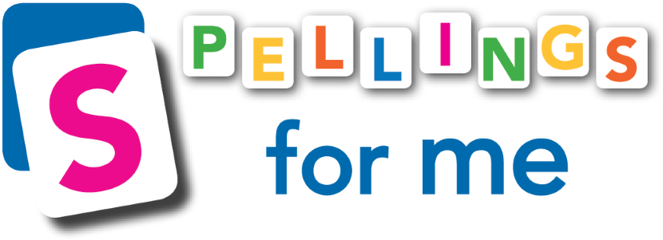
www.spellingsforme.ie info@spellingsforme.ie 01-5351661

2023/2024 Online Order Form

- If you would like to add extra students after the initial order, simply email us at info@spellingsforme.ie and we can look after this for you.
1. School Name:

2. Roll Number/ Identity Number:

3. Number of Online profiles Required:
(€5.28 +VAT per profile)€6.50 per student
4. School Address:

5. Total Cost:  Number of students x €6.50 | €
6. Telephone Number:

7. Your Email Address:
8. Ordered by:
(Name and position in the school)
9. Do you already have an account with Spellings for Me? Drag circle over your answer. | yes no
If yes, what is your School Personal URL?

*If you would like Spellings for Me to set up/organise students and teachers in your school, please fill out the information below. Please leave blank if you will do this yourself.
Set up is free. We recommend sending us this information before the summer break as wait times can be longer in September. It does not have to be sent in with the order form and can be sent at a later date.

10.A
If you wish to add new children to the programme, please provide a class list. Please include the standard and class teacher’s name.  (E.g., The title of the list could be ‘4th Class 21/22- Mr James Barry’) | You can attach this separately in your email. Please ensure that we can copy and paste from this attachment. E.g., Excel file, Aladdin file, Word document etc.

10.B Important: Students and teachers already uploaded to Spellings for Me will keep these same accounts year after year. They do not need to be uploaded again as this would result in duplicated users. Fill in the relevant information below and we will move these children on to their next class folder with the appropriate teacher. See example in Line 1.
Leave this section blank if this is not applicable to your school.
If you would like to do this yourself, please find instructions linked here.
You can also watch a useful YouTube video linked here.
Class Folder & Teacher 2020/2021 (Last year) |  |  | Class Folder & Teacher 2021/2022  (Forthcoming year)
3rd Class 20/21 | Mr John Smith |  | 4th Class 21/22 | Mrs Mary Doyle

Special Requests:

11. If you would like us to create teacher profiles, please fill in the grid below.
Note: We need individual, accurate email addresses for each teacher. This is how we communicate login details. Please do not provide the same email address for every teacher.
If teachers already have an account with us, you do not need to fill in their information below.
Teacher Profiles to be Created
First name | Surname | Email address | Class

14. If you would like us to delete users, please send us a list of pupils to be deleted. You can also do this yourself by following the instructions linked here. Teacher profiles can also be deleted.
Please email this form to info@spellingsforme.ie
Thank you!
If you have any questions or need assistance with this form, please do not hesitate to contact us.
www.spellingsforme.ie info@spellingsforme.ie 01-5351661

